# System Requirements Specification Index

For

# Snowflake web server log analysis using staging & custom functions

Version 2.0

IIHT Pvt. Ltd.

[fullstack@iiht.com](mailto:fullstack@iiht.com)

Problem Statement : snowflake webserver log analysis

Description : Use relevant methods operations toperform specified activities which are given in the instructions.

TechSolutions Inc. is a rapidly growing tech company that offers a suite of web-based applications to its global customer base. As the user base expanded, the volume of web server logs increased, making it challenging to monitor and analyze server performance and user activities.

*Objective*

TechSolutions Inc. aimed to implement a scalable solution to store, manage, and analyze web server log data to gain insights into user behavior, identify and troubleshoot errors, and optimize server performance.

*Implementation*

TechSolutions Inc. chose Snowflake for its scalable data warehousing capabilities and ease of handling time-series data. The following steps were taken:

* Steps to login in the snowflake account
* Use the credential given to you though your host

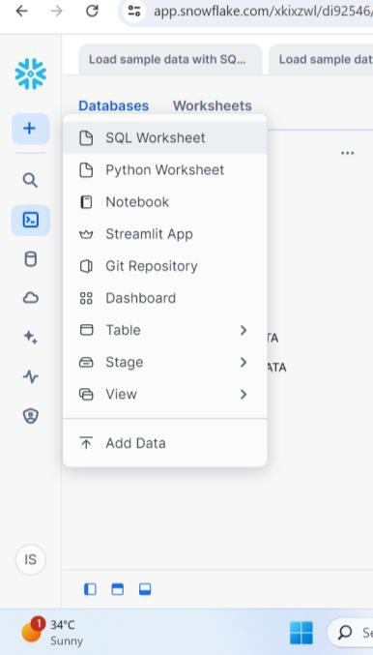

* Click on the sql worksheet to open the query editor

Sample data log

|  |  |  |  |  |
| --- | --- | --- | --- | --- |
| Timestamp | Log Level | Message | User ID | Session ID |
| 2024-06-30 08:00:00 | INFO | User logged in | alice123 | session001 |
| 2024-06-30 08:05:00 | ERROR | Failed to load page | alice123 | session001 |
| 2024-06-30 08:10:00 | INFO | User logged out | alice123 | session001 |
| 2024-07-01 09:00:00 | INFO | User logged in | bob_smith | session002 |
| 2024-07-01 09:15:00 | WARN | Slow response time | bob_smith | session002 |
| 2024-07-01 09:20:00 | ERROR | Page not found | bob_smith | session002 |
| 2024-07-02 10:00:00 | INFO | User logged in | charlie_007 | session003 |
| 2024-07-02 10:30:00 | INFO | Page loaded successfully | charlie_007 | session003 |
| 2024-07-02 11:00:00 | ERROR | Database connection failed | charlie_007 | session003 |
| 2024-07-02 11:15:00 | INFO | User logged out | charlie_007 | session003 |
| 2024-07-02 12:00:00 | INFO | User logged in | diana_king | session004 |
| 2024-07-02 12:10:00 | INFO | Page loaded successfully | diana_king | session004 |
| 2024-07-02 12:20:00 | WARN | High memory usage | diana_king | session004 |
| 2024-07-02 12:30:00 | ERROR | Service unavailable | diana_king | session004 |
| 2024-07-02 12:45:00 | INFO | User logged out | diana_king | session004 |
| 2024-07-02 13:00:00 | INFO | User logged in | eve_nash | session005 |
| 2024-07-02 13:05:00 | INFO | Page loaded successfully | eve_nash | session005 |
| 2024-07-02 13:15:00 | INFO | User logged out | eve_nash | session005 |
| 2024-07-03 14:00:00 | INFO | User logged in | franklin_92 | session006 |
| 2024-07-03 14:05:00 | ERROR | Login failed | franklin_92 | session006 |
| 2024-07-03 14:15:00 | INFO | User logged out | franklin_92 | session006 |
| 2024-07-04 15:00:00 | INFO | User logged in | george_t | session007 |
| 2024-07-04 15:10:00 | INFO | Page loaded successfully | george_t | session007 |
| 2024-07-04 15:20:00 | WARN | Unexpected input | george_t | session007 |
| 2024-07-04 15:30:00 | ERROR | Session timeout | george_t | session007 |
| 2024-07-04 15:45:00 | INFO | User logged out | george_t | session007 |
| 2024-07-05 16:00:00 | INFO | User logged in | hannah_b | session008 |
| 2024-07-05 16:05:00 | INFO | Page loaded successfully | hannah_b | session008 |
| 2024-07-05 16:15:00 | ERROR | Payment failed | hannah_b | session008 |
| 2024-07-05 16:30:00 | INFO | User logged out | hannah_b | session008 |

Task A STAGING IN SNOWFLAKE

1. Create a custom user stage with the database
2. Install vs code and add snowflake extension connect to the snowflake account from vscode
3. Create a new table to store the table
4. Load the stage data in the table
5. Query the weblog table to view data have been imported successfully

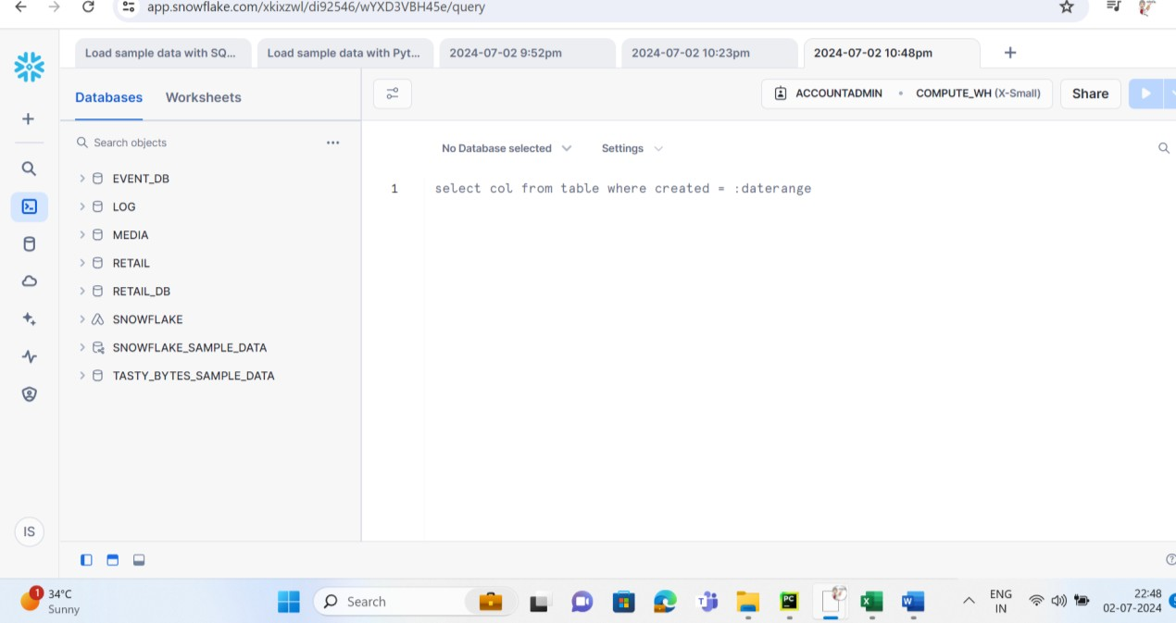

* Click on the database icon on the left side in the console

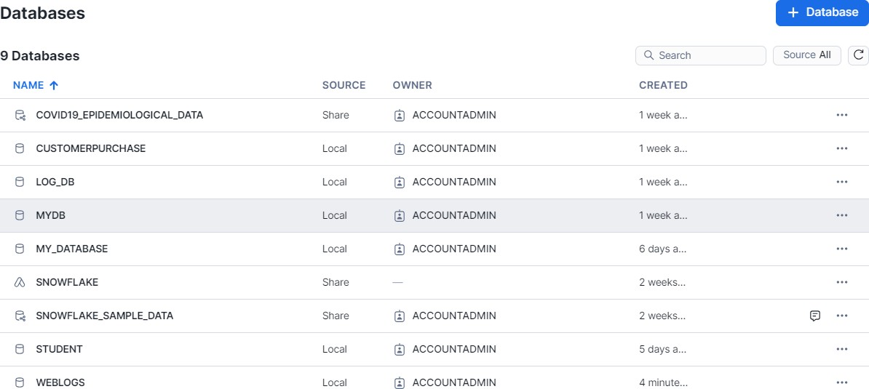

* Create a database give it name weblogs
* Now click on Create - >Sql worksheet
* Select the database like show in the image we have created weblogs
* Select the same database name and schema name .

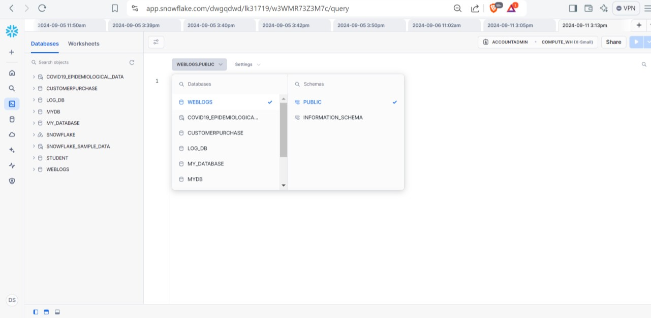

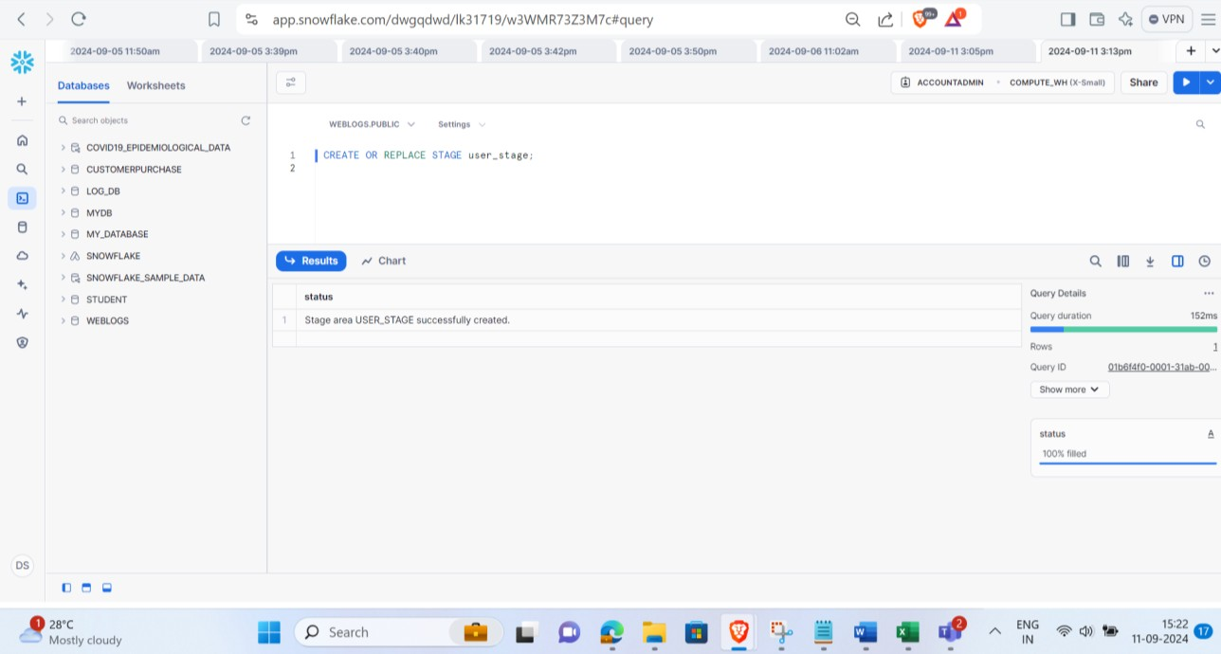

* Open VS code go to extensions search for snowflake and install .

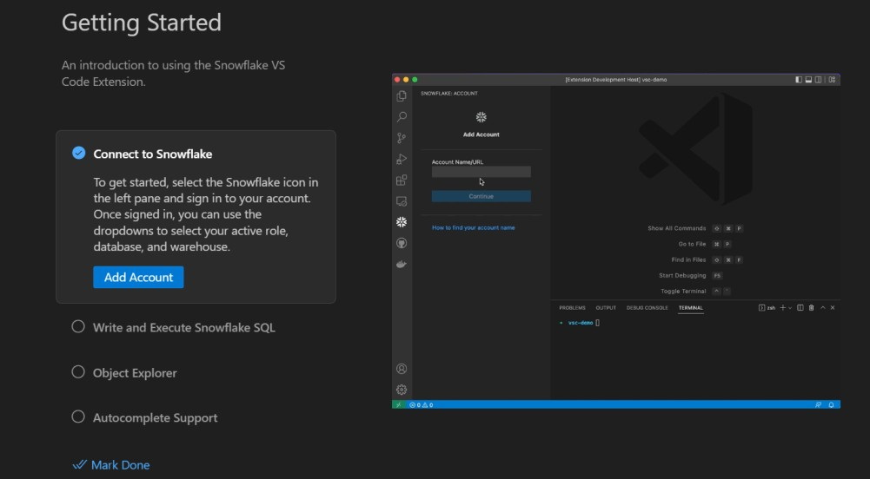

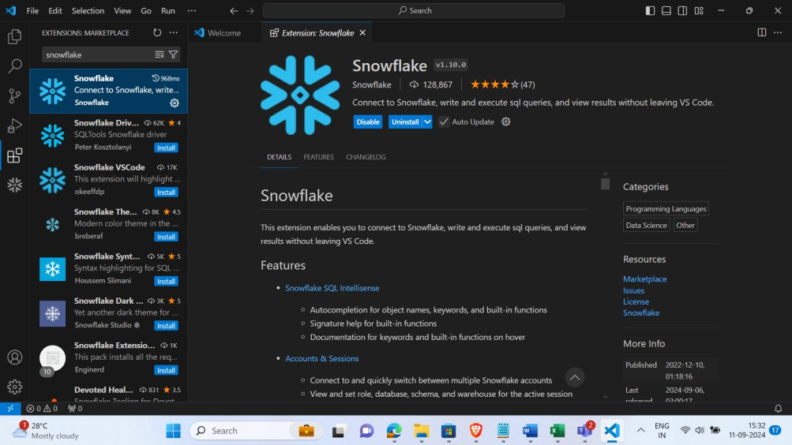

* Click on the install button
* You need to get the account ID from the snowflake console

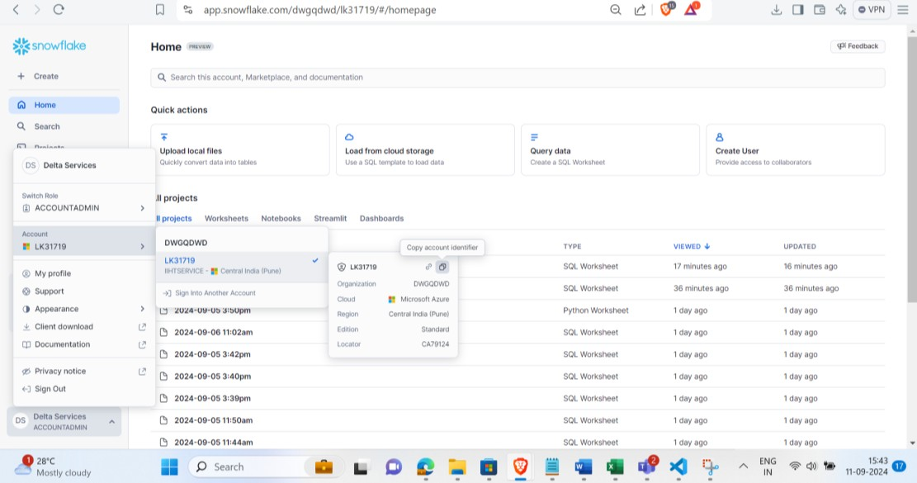

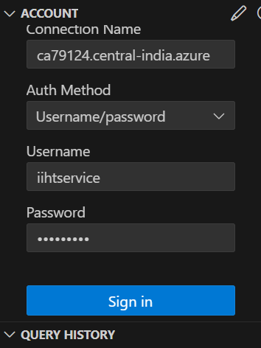

* Authenticate to the snowflake account
* Create the staging environment you can use the same structure from the screenshot you must get the similar output .

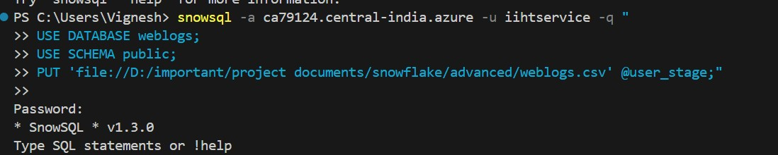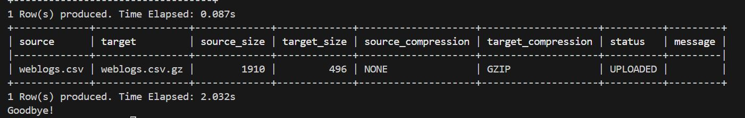

* Creating the table for data to be imported to the table

•

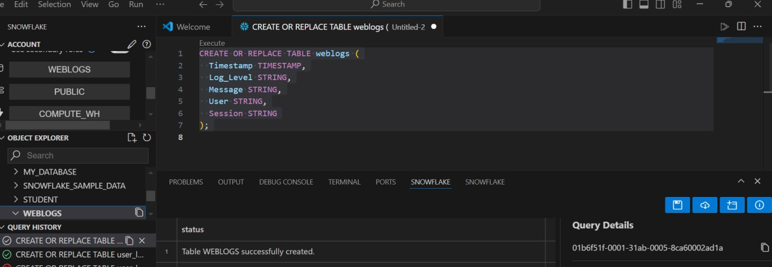

* Create the userstage using the following query

Sql code CREATE OR REPLACE STAGE user_stage;

* Create the table by selecting the weblogs database .

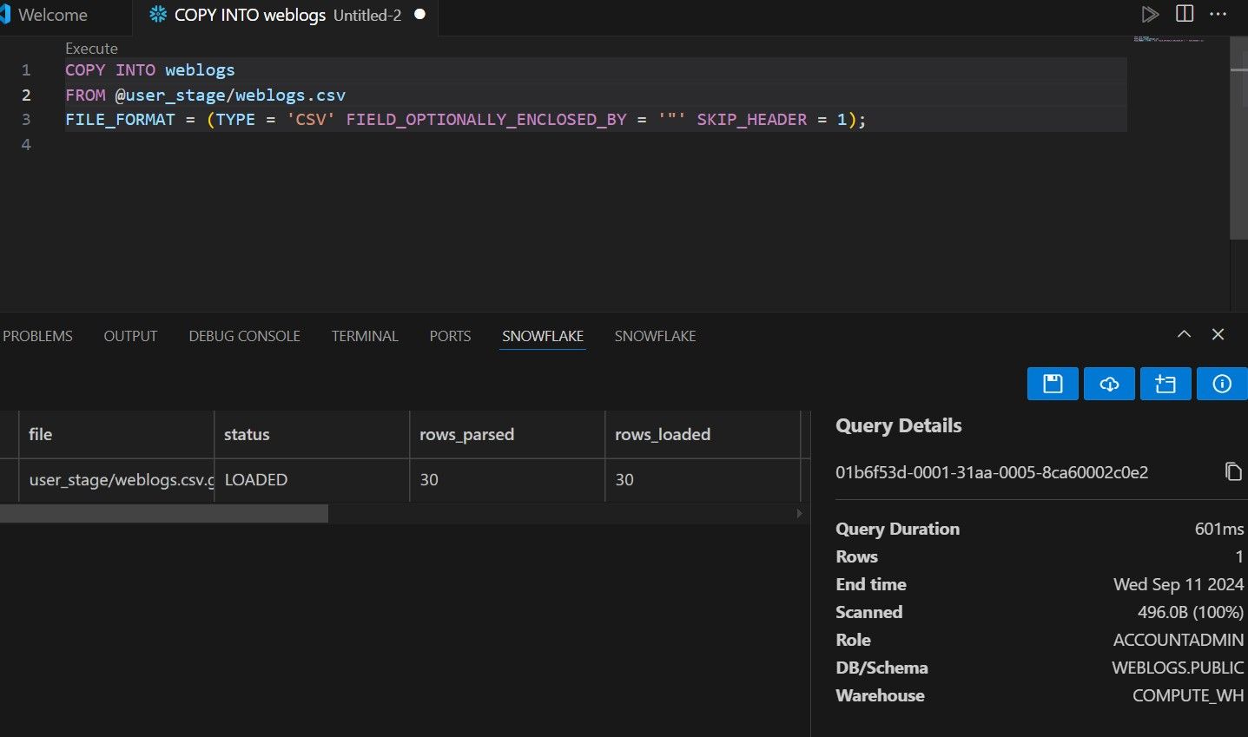

### Query the database

* SELECT * FROM weblogs;

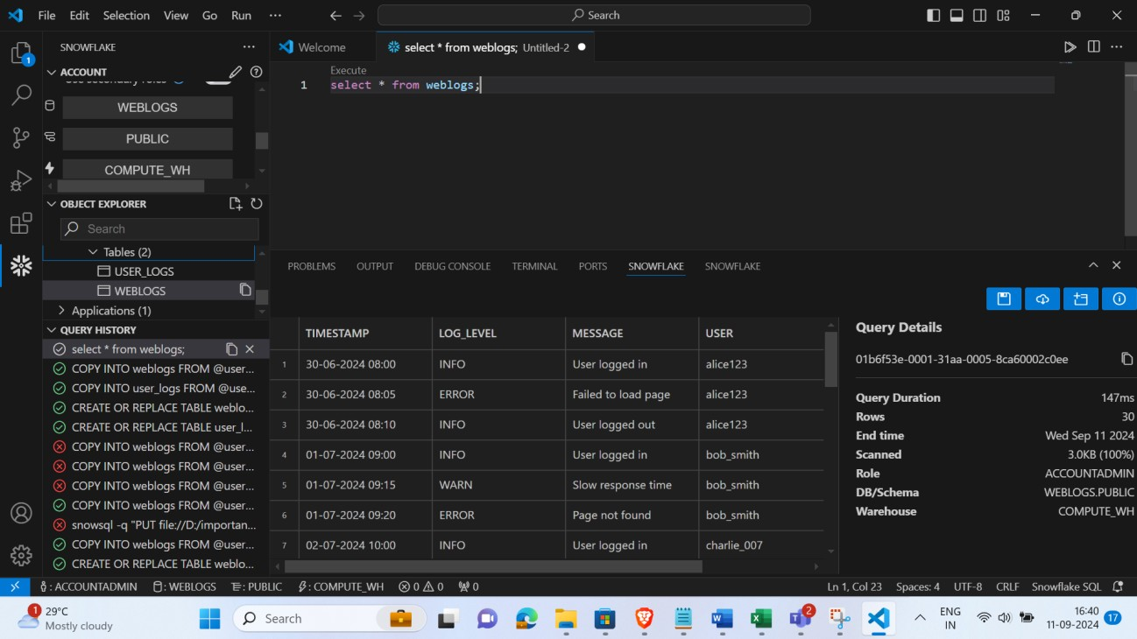

* Once you have imported the table check for respective rows and columns are imported correctly.

**Task B Perform operation with the table**

1. Retrieve all logs for a specific user? “'hannah_b'”
2. Count the number of errors in the logs
3. Retrieve logs within a specific time range 4 Group logs by log level

5 Find the most recent log entry for each user

## Task C Perform UDF function stored procedure

1. Connect to Snowpark with database created.
2. Create a categorize_log_level UDF function “Critical," "Warning," or "Normal” and print

the results

1. Create and register the filter_and_categorize_logs stored procedure 4.Test the Stored Procedure
2. .Check the stored procedure for the user “hannah_b”
3. Execute and Validate the stored procedure for hannah_b_categorized_logs .

Note please create the categorize_log_level function with the same name

## To Connect to Snowpark you can use any editor ( template to connect to snowflake )

from snowflake.snowpark import Session

session = Session.builder.configs({ "account": "<your_account>", "user": "<your_username>", "password": "<your_password>", "role": "<your_role>",

"warehouse": "<your_warehouse>", "database": "<your_database>", "schema": "<your_schema>"

}).create()

### Execution Steps to Follow:

* 1. Open the snowflake console
  2. Import the dataset from the document
  3. Perform all the query respective to the question provided
  4. Take screenshots of the query execution
  5. Upload the code to the Github

### -----x-----